FBDA Nomination Form 2023
Nominations must be submitted by 16th August 2023.

Shortlisted Nominees will be contacted by 28th August 2023.
AWARD CATEGORIES
1. Health and Disabilities Employee
2. Young people (16-24) Employee
3. Adults 25+ Employee
4. Achiever of the year (all ages)
5. Healthy Workplace Employer
6. Employability Award
This year’s nomination categories are as follows:
EMPLOYEE AWARD (Category 1-3)
Winners will be in paid work. We would like to hear about individuals who have overcome significant disadvantages, disabilities, health conditions, personal, physical or social barriers and undertaken a range of activities to find a paid job.
Complete Section 1
ACHIEVER AWARD (Category 4)
Winners will be on their journey to work and still in search of a paid job. We would like to hear about individuals who have overcome significant disadvantages, disabilities, health conditions, personal, physical or social barriers and have undertaken a range of activities whilst on their journey to find a paid job.
Complete Section 1
HEALTHY WORKPLACE EMPLOYER (Category 5)
Workplaces come in all shapes and sizes. Healthy workplaces have a few things in common:
· Staff morale is high
· People feel good about coming to work
· People from all backgrounds are part of the workforce and everyone is made to feel welcome and valued.
· The employer cares about their employees’ wellbeing and manage risks to improve mental health in the workplace
· The employer has a great reputation in the community
· There is a zero tolerance approach to discrimination
We want to hear about businesses based in Fife who are committed to Healthy Workplaces through practice and policy. Here are some examples of a healthy workplace:
· The business has DWP Disability Confident status levels 1, 2 or 3, Investor’s in People or Inclusive Workplace awards.
· They are involved in campaigns to improve their workforce wellbeing such as Mates in Mind, Fife’s Just Ask Listen talk pledge or have run in house initiatives to encourage good health at work.
· Staff undertake equality, diversity and disability awareness training
· They sponsor local groups such as football teams or allow their employees to volunteer in the community.
Complete Section 2
EMPLOYABILITY AWARD (Category 6)
Winning businesses, organisation or individuals will have introduced, developed or sustained practices that improve the employability journey for people who are disadvantaged in the labour market. This helps individuals acquire person attributes, capacity, confidence, skills and learning that helps them prepare for, find and stay in work. Here are examples of good employability practices:
· Employability providers who have developed and delivered a new programme that improves people’s chances of finding a job.
· Introduction of a policy that supports people who are struggling at work or off sick due to their personal experiences e.g. people with disabilities, returners after maternity or adoption leave, people with caring responsibilities.
· An employer who is working alongside Fife’s No One Left Behind Provision to provide work placements or paid jobs for individuals from diverse backgrounds
· An individual or organisation who has introduced innovative practice to provide opportunities for people who are furthest removed from the labour market.
Complete Section 3
SCORING
You will complete Section 1, 2 or 3 relevant to your chosen category. Statements are shown in each section that are indicators of good achievement, outcome or practice relevant to your chosen category. You will be scored for all statements ticked, but only where you have provided supporting written evidence in the space below the statement. You can refer to more than one piece of evidence to support each statement too e.g. Overcoming personal barriers or difficulties: The nominee is a lone parent with two children, one of the children has a physical disability. This person has no family support network. They are also experiencing housing difficulties due to inaccessibility for the disabled child and currently seeking advice and support for accommodations to the home.
Your supporting written evidence is rated and scored as follows for each statement you respond to:
Rating and score: 1= low level or only one example
Rating and score: 2= medium level or one to three examples
Rating and score: 3= significant level or four or more examples
You can submit multiple nominations, but must use a separate form each time.

Fife Business Diversity Awards 2023
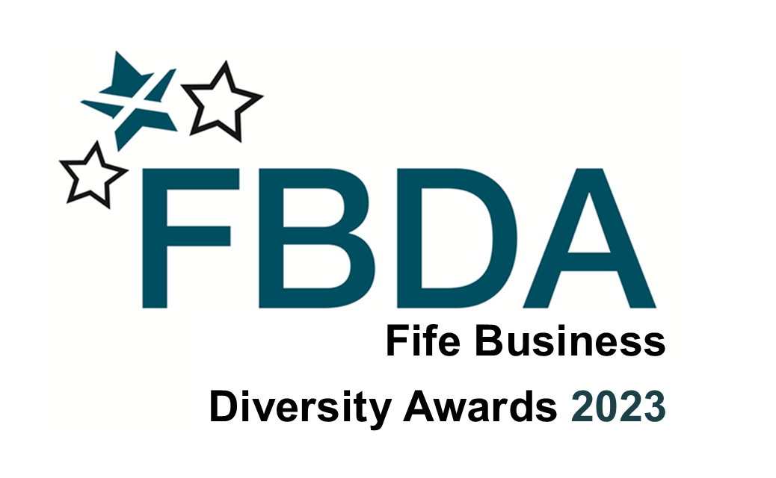
Nominee Name: __________________________________________________

Nominee Address: __________________________________________________
__________________________________________________
__________________________________________________

Nominee Contact (phone number and email): ______________________________
__________________________________________________
Nomination Categories
Circle or highlight your chosen category – only one category can be highlighted per form. A description of the categories is shown below:
- Employee Award – Health & Disabilities (COMPLETE SECTION 1)
- Employee Award – Young People (16-24) (COMPLETE SECTION 1)
- Employee Award – Adults (25+) (COMPLETE SECTION 1)
- Achiever Award (COMPLETE SECTION 1)
- Healthy Workplace Employer (COMPLETE SECTION 2)
- Employability Award (COMPLETE SECTION 3)

SECTION 1: EMPLOYEE AND ACHIEVER NOMINATION (CATEGORIES 1-4)
Introduction Summary: Provide a 150 word summary on your nomination. This will be used for publicity.
Suggested headings are:
The nomination is for…
The disadvantages or challenges the nominee has overcome are…
The nominee has been supported on their journey by…
The nominee has managed to achieve…
Following the Introduction Summary, we have provided statements applicable to this category. This is your opportunity to give further details on your nominee’s achievements, outcomes or good practices in several key areas. You can repeat some of the information provided in your Introductory Summary.
Please tick all the statements that apply to your nominee. In the box(es) underneath the statement, provide written evidence of no more than 100 words for each statement ticked. The information you provide under the statement will translate to a score as described previously.
If the statement does not apply to you nominee, write N/A in the box underneath.

Introduction Summary (Maximum 150 words)

Overcoming personal barriers or difficulties
Overcoming disability and/or health issues
Overcoming social barriers
Exceptional determination
Willingness to go the extra mile (e.g. considering different options)
Engaging in, and attending appointments/courses
Training to achieve employment goals
Personal motivation
Maintaining a positive outlook
Playing a proactive role in finding work
Influencing others positively
Using initiative
Employment progression/paid employment achieved
Other please specify

You are welcome to provide supporting information e.g. a quote from the individual nominated, work colleagues, customers and manager. (Maximum 300 words and up to 5 additional points)

Nominations will only be accepted where the Data Protection and FBDA Nominee Consent Form for Publicity Release are signed and agreed by the nominator and the nominee. Go to Next Steps and Declaration.

SECTION 2: HEALTHY WORKPLACE EMPLOYER NOMINATION (CATEGORY 5)
Introduction Summary: Provide a brief 150 word summary on your nomination. This will be used for publicity. Suggested headings are:
The nomination is for…
The nominee undertakes a range of activities that show they have a healthy workplace such as……
Employees are provided with…
Employees are encouraged to….
Following the Introduction Summary, we have provided statements applicable to this category. This is your opportunity to give further details on your nominee’s achievements, outcomes or good practices in several key areas. You can repeat some of the information provided in your Introductory Summary.
Please tick all the statements that apply to your nominee. In the box(es) underneath the statement, provide written evidence of no more than 100 words for each statement ticked. The information you provide under the statement will translate to a score as described previously.
If the statement does not apply to you nominee, write N/A in the box underneath.

Introduction Summary (Maximum 150 words)

Inclusive recruitment practice such as adverts for jobs in local buildings or local social media platforms, tailored recruitment and interview practice for candidates with multiple barriers etc
Disability Confident Employer/Evidence of creating and sustaining a mentally healthy workplace/Signed up to Just Ask, Listen, Talk or other employer initiatives that show health, equality and diversity practices etc
Provide flexible working opportunities and have applied accommodations/adjustments in the workplace such as adjustments to the job remit or hours to suit individuals, early/late/flexible hours, accommodation for caring responsibilities, school hours, adapted duties, equipment or resources etc
Staff undertake training in topics such as equality, diversity, disability awareness, good health and mental wellbeing etc
Involved in local community – sponsor local events or groups, allow staff to participate in voluntary activities during work time etc
Offer one on one support to staff who are finding it difficult to stay in work or return to work due to poor mental health or physical wellbeing, disabilities or health conditions etc
Other, please specify

You are welcome to provide supporting information e.g. a quote from the individual nominated, work colleagues, customers and manager. (Maximum 300 words and up to 5 additional points)

Nominations will only be accepted where the Data Protection and FBDA Nominee Consent Form for Publicity Release are signed and agreed by the nominator and the nominee. Go to Next Steps and Declaration.

SECTION 3: EMPLOYABILITY AWARD NOMINATION (CATEGORY 6)
Introduction Summary: Provide a brief 150 word summary on your nomination. This will be used for publicity. Suggested headings are:
The nomination is for…
The nominee has developed, sustained or introduced …
This was achieved by…
The outcome of this has been…
Following the Introduction Summary, we have provided statements applicable to this category. This is your opportunity to give further details on your nominee’s achievements, outcomes or good practices in several key areas. You can repeat some of the information provided in your Introductory Summary.
Please tick all the statements that apply to your nominee. In the box(es) underneath the statement, provide written evidence of no more than 100 words for each statement ticked. The information you provide under the statement will translate to a score as described previously.
If the statement does not apply to you nominee, write N/A in the box underneath.

Introduction Summary (Maximum 150 words)

A new employability programme
Good practice or new policy to support people who are struggling at work or off sick due to their personal experiences e.g. people with disabilities, returners after maternity or adoption leave, people with caring responsibilities
Innovation in employability and evidence of success
Improvement in recruitment and selection of people from diverse backgrounds
Flexible approaches to training or employability programme or recruitment & retention
Evidence of partnership working
Increased employer engagement
Other please specify

You are welcome to provide supporting information e.g. a quote from the individual nominated, work colleagues, customers and manager. (Maximum 300 words and up to 5 additional points)

Nominations will only be accepted where the Data Protection and FBDA Nominee Consent Form for Publicity Release are signed and agreed by the nominator and the nominee. Go to Next Steps and Declaration.

NEXT STEPS AND DECLARATIONS
Nominations will only be accepted where the Data Protection and FBDA Nominee Consent Form for Publicity Release are signed and agreed by the nominator and the nominee
DATA PROTECTION
The Opportunities Fife Partnership takes Data Protection seriously and is committed to ensuring that privacy is protected.
Purpose of processing and legal basis
The personal data and information on this form is being collected for the purpose of Fife Business Diversity Awards 2023.
The information submitted on this form will be used by a named judging panel to choose Award Winners.
The award winners’ name and image by photograph will be made public at the Fife Business Diversity Awards Ceremony.
The award winners name, and information submitted in section 1, 2 or 3 of this form will be used for Local and National press release, for hard copy Fife Business Diversity Awards publications, to promote Fife Business Diversity Awards, to promote Opportunities Fife Partnership Employability provision hard copy and on line for a period up to 12 months following the FBDA Award Ceremony.
Nominees personal details - address, email and contact details will not be publicised in any way nor sold, distributed or released to third parties unless we have the nominees written permission or are required by law to do so. We comply with the Data Protection Act 1998 and GDPR (May 2018) when handling nominees personal information.
If the nominator or nominee has any concerns about how we use the nominees personal information contact dataprotection@fife.gov.uk
By signing this form the nominator confirms they have discussed the Data Protection section with the nominee and the nominee consents to the processing of their personal information for the above purpose.
Please tick a box below:
YES
NO

Nominator to Print Name as signature ____________________________________
Date: __________________________________________
Nominator Address: __________________________________________
__________________________________________
__________________________________________
Nominator Contact details (email and phone number):
__________________________________________
__________________________________________

FBDA NOMINEE CONSENT FORM FOR PUBLICITY RELEASE

We require nominees to share the details of their nomination at the FBDA event and up to 12 months following the event. This will be shared through video, photographs and/or interview. We will decide how to share this information to suit individual preferences as shown below in the consent boxes.

The nominator must complete this form as evidence that:
- They have discussed use of nomination information for publicity release with the nominee
- The nominee is willing to share their name, image and information related to this nomination (case study) with our event audience and through digital and written platforms such as photographs or video or testimonial evidence or written press release; shown in a range of media outlets and written materials including websites and product or information booklets during and after the event.

Name of person/business/employer giving consent: (print name clearly)

Please tick () the boxes below where the nominee has agreed to give their consent:

I, the nominee, give my consent to use my name/case study/image in the following ways: | Name | Image/video interview | Case study/Information from nomination
In a wide range of publicity materials e.g. booklets, digital media (e.g. websites), feature articles (magazines), radio, TV, local newsletters and newspapers, You Tube, presentations, Tik-Tok, Twitter, Facebook, Instagram, exhibition stands, posters etc

We, the nominator and nominee, agree and understand:

- This consent will be available for use for a period of 24 months. Although materials may be in circulation longer than 24 months using this consent, no new materials or publicity will be produced based on your consent after that period.
- Consent can be withdrawn by contacting sw.ses@fife.gov.uk
- During the period that consent is provided, we may contact the nominee or nominator to gather more information.

Nominee to Print Name as signature ____________________________________
Date: __________________________________________
Nominee Contact details (email and phone number):
__________________________________________
__________________________________________
FINAL INSTRUCTIONS:

Please return your form to linda.clark@fife.gov.uk

Fife Business Diversity Awards are unique to Fife in celebrating the employment benefits for people who are disadvantaged in the labour market.
The event would not be possible without sponsorship.
Please contact Linda Clark on 01592 583142 or Linda.clark@fife.gov.uk to find out more about the range of sponsorship opportunities available.

The Judging Panel
Our judging panel will consider all correctly completed nominations and agree on a shortlist of potential winners in each of the categories. Judges may transfer nominations from one category to another for the benefit of the nominee if they feel this is appropriate.
If your nomination is short listed, you and your nominee will be informed by 28th August 2023 at which stage we will discuss best ways of providing information about your nominee at our event, such as through video, photographs or interview. You will both be invited to attend the Fife Business Diversity Awards 2023 ceremony on Friday 1st December 2023 at The Bay Hotel, Burntisland.
GOOD LUCK!

