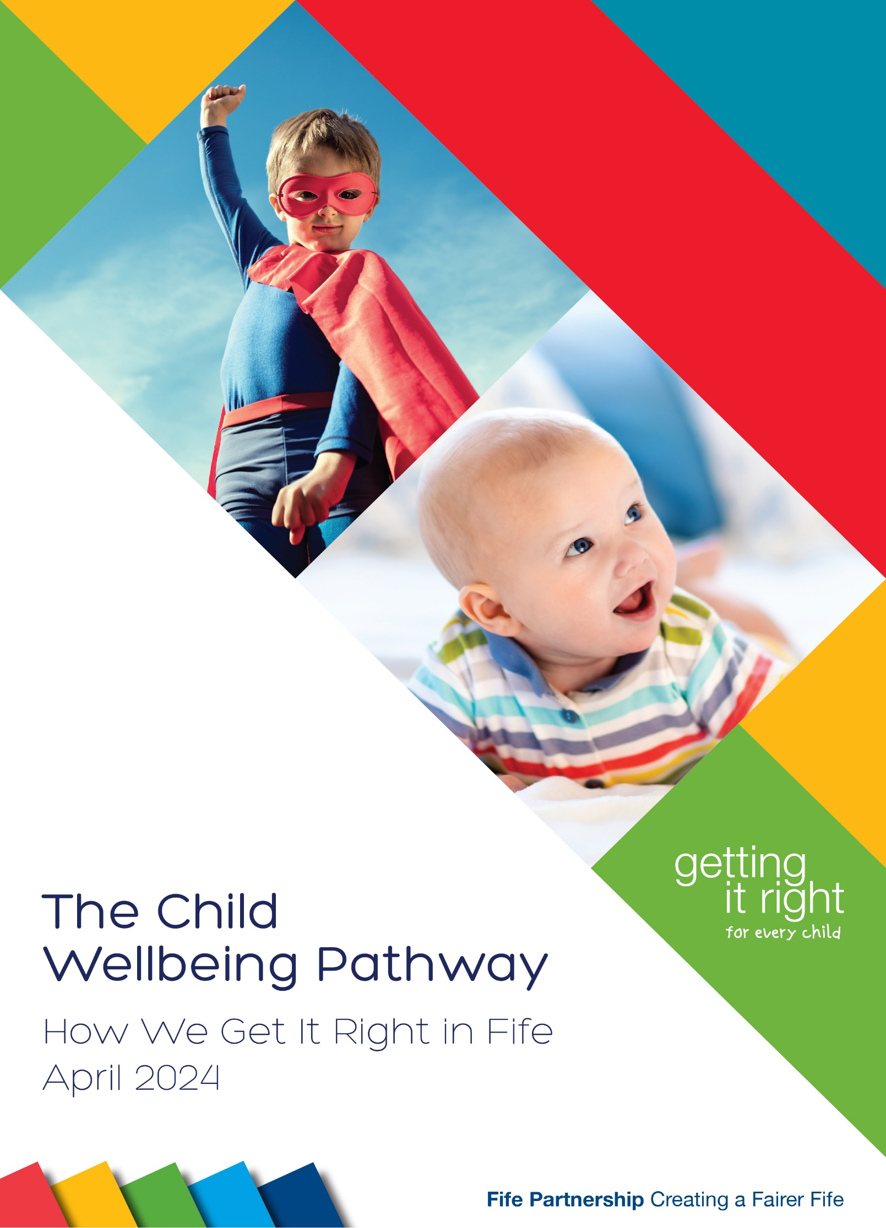
Contents

1.1 Introduction 2
1.2 Key aims of this guidance 2
2.1 How We Get It Right- National Guidance 3
3.1 Universal Provision - supported by the named person 4
3.2 Universal Support -Role of a named person 4
4.1 Assessment of Wellbeing 6
4.2 Chronologies and Assessment 6
5.1 A Team Around the Child Approach - Additional and Intensive Support 7
5.2 Accessing Support beyond Universal Services. 8
6.1 Team Around the Child Meetings 9
7.1 Role and responsibility of a lead professional 11
8.1 Child Protection concerns 12
9.1 Children & Families Social Work Service 12
10.1 Information Sharing – to support decision making 13
10.2 Should the child, young person or family be asked for consent? 13
10.3 Can you share personal information without consent? 14
10.4 Who can give consent? 15
10.5 Police Information 15
10.6 Social Work Information 15
10.7 When there are siblings involved. 15
10.8 Storing Information 15
Appendix 1: Fife Child Wellbeing Pathway Flowchart 16
Appendix 2: Lead professional Dispute Resolution Process 17
Appendix 3: Sharing Information Flowchart 18

1.1 Introduction
___________________________________________________________________________
The Child Wellbeing Pathway (CWP) outlines the practice and process Fife Children’s Services Partnership follows to ensure wellbeing needs and concerns are addressed to get it right for all children and young people. The Getting It Right in Fife Framework (GIRIFF), updated in May 2023 provides the overarching framework which underpins practice for everyone in Fife.
Click here for GIRIF framework:
Key to successful implementation of Getting it Right for Every Child are the 5 GIRFEC questions to address wellbeing needs and concerns in a timely way.
The GIRIFF is based on the concept of a continuum of need; core principles and collaborative practice to address wellbeing needs and concerns early and proportionately. The framework confirms the core practice principles adopted by the partnership; roles and responsibilities of a named person and lead professional; key changes within the new national GIRFEC guidance and illustrates the range of services across the continuum of need which are accessible in Fife. It is important that everyone is familiar with the contents of the GIRIFF which provides the context to the Child Wellbeing Pathway as the key process in Fife to deliver Getting it Right for Every Child (GIRFEC).
The refresh of the CWP takes account of the updated Scottish Government GIRFEC practice guidance; national Child Protection guidance; key policies and legislation such as the UNCRC; The Promise, Whole Family Wellbeing; feedback from the workforce and learning from case reviews in Fife.
The guidance is designed to support practitioners to work in partnership with children/young people, their families/carers, and other services. It also supports the development of practice in relation to carrying out effective single and multi-agency assessments of wellbeing to inform effective interventions through co-ordinated planning. The CWP guidance has been shortened and the flow chart updated, also several embedded links are within the guidance which should be considered to effectively implement this key process for the benefit of Children; Young People; Families; and Carers (C&YPFC) in Fife.
1.2 Key aims of this guidance are to:
Key aims:
Provide practitioners with a clear pathway that helps them to assess and identify wellbeing needs and concerns and to plan appropriately.
Clarify roles and responsibilities of all practitioners working with families to address wellbeing needs and concerns.
Highlight best practice principles and the application of national practice tools for practitioners assessing wellbeing needs and concerns.
Support practitioners in understanding how to gather and share information that is relevant to the assessment of wellbeing and coordination of support as part of a child’s plan.
Offer guidance on how to work in partnership with all stakeholders including C&YPFC.
Support practitioners to make informed judgements about when identified needs and risks may require additional or intensive support and processes to follow to ensure effective planning with the child or young person at the centre.
2.1 How We Get It Right- National Guidance
___________________________________________________________________________
The CWP promotes the use of the Wellbeing indicators (Safe, Healthy, Achieving, Nurtured, Active, Respected & Responsible, Included - SHANARRI) in single and multi-agency assessments of wellbeing. The national GIRFEC guidance refers to a strength-based approach with new language for example challenges rather vulnerabilities. This has been considered in terms of a more family focused assessment approach, which is still underpinned by the wellbeing indicators but is more accessible to families in terms of language. It also provides a process and structure for implementing effective co-ordinated interventions and planning.
In Fife the CWP is the agreed assessment, intervention, and planning pathway for C&YPFC. Following careful consideration of the recent national guidance and reviews on how the CWP is working in practice through consultation with the workforce this guidance and the GIRIFF takes account of the following:
The Child Wellbeing Pathway takes account of:
Role of named person and lead professional endorsed by the Children’s Services Partnership.
Access to a named person for C&YP up to the age of 18 yrs.; young people transitioning from education before 18 years and other specific groups.
Tools to support assessment and analysis for example chronologies, national practice model, risk assessment framework.
Good practice in terms of multi-agency planning and sharing information.
The importance of timely and flexible support rather than a reliance on a meeting to mobilise support.
Relationship based practice underpinned by a rights-based approach.
Sharing of information with the named person and Third sector organisations
Lead professional dispute resolution process.

This refreshed guidance seeks to provide further clarity on the points above but also reinforce the approach in Fife from early intervention and assessment of wellbeing by single agencies and named persons at a universal level. It also focuses on a multi-agency response involving a Team Around the Child Approach (TAC). The updated Wellbeing Pathway Flowchart (appendix 1) seeks to reinforce the Fife approach but should not be viewed as an incremental process.
Wellbeing needs can vary over time and on occasions can require a more immediate multi-agency response (Child Protection). The CWP flowchart is a guide with reference to key sections in this guidance which provide detail on practice standards to improve outcomes for C&YPFC.

A key language change in the guidance and GIRIFF is a Child Wellbeing Meeting is now referred to as a Team Around the Child (TAC) Meeting .

3.1 Universal Provision - supported by the named person
___________________________________________________________________________

The practice in Fife and for most Children’s Services Partnerships nationally, the named person for children and young people will be provided by the following practitioners at the identified ages and stages.

Named person roles
Birth to primary school entry | Health Visitor or Family Nurse
Primary School | Head Teacher or Depute Head Teacher
Secondary School | Guidance teacher (or other promoted member of school staff)

For any unborn child where there are child protection concerns the midwife and/or Vulnerable in Pregnancy midwife supports a coordinated approach prior to birth.

Link to interim interagency pre-birth pathway.

The refreshed GIRFEC national guidance confirms the support of a named person is available to all C&YPFC, however there is NO obligation on C&YPFC to accept the offer of support or advice. Some families may have access to more than one named person due to ages of children in the family, these named persons and other services involved with the C&YPFC MUST work closely to assess and coordinate support alongside the family. Access to a named person is in place until a young person reaches 18 yrs. Current processes are in place to ensure a key point of contact in Education is available during school holidays or for home educated children and young people.

3.2 Universal Support -Role of a named person

The national guidance states ‘The named person promotes good wellbeing and forms relationships through the provision of a universal service. They are a clear point of contact for ANYONE concerned about the child or young person’s wellbeing whether this is the child, or young person themselves, parents, family members or others working with the child or young person.’

The following 5 GIRFEC questions are relevant to all agencies in contact with children, young people, families, and carers where there may be wellbeing needs.

- What is getting in the way of this child’s or young person’s well-being?
- Do I have all the information I need to help this child or young person?
- What can I do now to help this child or young person?
- What can my agency do to help this child or young person?
- What additional help, if any, may be needed from others?

The named person is responsible for coordinating the assessment of wellbeing to address identified needs and concerns alongside the C&YPFC with any other relevant agency. The named person is NOT responsible for the support offered by other services but has a role in coordination of support. This approach supports the aims of GIRFEC to mobilise support early and in the least intrusive way.

When a practitioner from a children’s service becomes involved with a child/young person they should link with the named person, this supports them to effectively carry out their responsibilities, and ensure C&YPFC get the support they need.

The wellbeing flow chart places an emphasis on early coordination of support which does not always require a formal meeting and can be part of an agreed plan of support coordinated by the named person. However, if there is more than one service involved and additional needs are identified good practice involves a meeting with the family and relevant professionals to consider together the challenges, areas of support, and agreeing together a child’s plan which is subject to clear timescales and review. In cases where wellbeing needs can be addressed by universal services or Third Sector organisations the named person will also be the lead professional and will coordinate and review the support in place. If assessment of wellbeing indicates additional or intensive support is required, this requires a TAC approach which is outlined in section 5 and the CWP flowchart.

4.1 Assessment of Wellbeing
___________________________________________________________________________
Any assessment of a child or young person should always ensure that they and their wellbeing needs are at the centre. Effective assessment is a continuous process that involves gathering and analysing information over time, across contexts, with the child/young person and their parents/carers, and potentially with practitioners from other services. A one-off assessment in an isolated context is unlikely to identify the holistic wellbeing needs of a child/young person, though it may help highlight specific issues of concern.

Principles of effective assessment of wellbeing include:
Taking a child and whole family centred approach.
Minimal intervention as early as possible to achieve the best outcome.
Collaborative working in partnership with the child/young person, their family, and others who work with them.
A focus on identifying needs and risks.
Identification of strengths and protective factors building capacity and resilience.
Effective and proportionate interventions.
Input from partner services to complement assessment and support planning.
A clear analysis of the information gathered to inform decisions.
Current and historical factors which impact on the child.
An evidence-based approach.

The CWP flowchart, and associated assessment tools, provide guidance and practical frameworks to support practitioners to carry out an effective and proportionate assessment of wellbeing. The National Practice Model which includes the My World Triangle, Wellbeing Indicators, and Resilience Matrix provide tools for assessing wellbeing.

4.2 Chronologies and Assessment

Initiating and maintaining a single or multiagency chronology is an important aspect of ongoing assessment. An accurate and up-to-date single or multiagency chronology supports the collation and analysis of key information about significant events in children’s lives and the single and/or cumulative impact these can have on their wellbeing.
Please refer to the Single and Multi-Agency Child Chronology Good Practice Guidance to support your practice of incorporating a chronology into a robust contextual assessment either as the named person or as the Team Around the Child when there is more than one service involved.
Link to Fife Chronology guidance:
It is expected that practitioners will use their single agency chronology to support and inform multi-agency assessment of a child/young person, and to help inform their contributions to planning e.g., at a Team Around the Child Meeting.
5.1 A Team Around the Child Approach - Additional and Intensive Support
___________________________________________________________________________

Some children/young people will require input from more than one agency/service to fully assess, plan and address wellbeing needs and areas of concern. The CWP flowchart outlines the process of moving from single to multi-agency working, as part of early and effective intervention . Effective engagement and involvement of the C&YPFC is central to practice as part of a relationship-based approach.

Working in partnership is crucial to ensure that wellbeing needs are fully assessed, identified, and planned for appropriately. Bringing together shared assessments - across more than one service requires a good understanding of and commitment to effective partnership working.
Link to child’s plan guidance:

Some of the key principles of effective partnership working include:
Shared set of core values, principles, and priorities.
Agreed focus on meeting the needs of children/young people and their parents/ carers.
Commitment to working together with an agreed vision and strategy.
Understanding of and respect for each other’s working practices.
Clarity about respective roles and responsibilities.
Flexibility and willingness to support colleagues.
Effective communication, shared approaches to assessment, and joint decision making.
A shared use of language and terminology that is understood by everyone.
A solution focused approach.
A strength based and co-production approach to planning with the C&YPF.
Commitment to resolving any difficulties early and constructively.

5.2 Accessing Support beyond Universal Services.

Awareness of the range of support services across Fife, access points and roles and responsibilities of different agencies is critical to ensuring early access to support for C&YPFC. Understanding the service offer and information required to be submitted is essential to avoid delay. On this basis early contact with a service to discuss the reasons for considering support is an important step to agree the support that needs to be in place. By having a clear understanding of each services offer this should support a more seamless approach for C&YPFC and avoid delay.

The CWP flowchart illustrates the importance of accessing services in an early and proportionate way, in collaboration with the named person who acts as a single point of contact if wellbeing needs are identified. For support at a universal level, services can be put in place without having to move to a formal meeting.

A key element of early and effective planning to address wellbeing needs is working in partnership with the named person. However, for services at an additional and intensive level a Request for Assistance or referral may be required when there is a need for more than one agency to respond to wellbeing needs and concerns. A referral to the Social Work Service or Family Support Service from the named person must be accompanied by the current child’s plan and a chronology. Based on the assessment of needs and risks there should be no delay in submitting a referral to Social Work.

Outcomes from making a Request for Assistance (RfA) or referral to any service can include:
The service agreeing to become involved for a specific purpose OR
The service seeking additional information prior to agreeing their involvement, this will involve discussion between the named person and the service OR
A recommendation that an alternative service might be more appropriate for example a universal service offered by the Third sector based on assessment.
For C&YPF requiring additional/intensive support from the Family Support Service or C&F Social Work, this would be via the Social Work Contact Centre, using the referral form (including a chronology and a child’s plan).

Family Support Service Guidance:
Family Support Service Referral:

Referral to Social Work Guidance:

Referral to Social Work form:

This approach relies on partnership discussion and agreement on the outcome to ensure a Whole Family Wellbeing approach.

If a RfA/ referral is accepted by a specific service, there should be agreement about how to initiate contact with the C&YPCF alongside the named person. In all cases there is the expectation that C&YPFC are fully aware of the decision to seek involvement of another service and their views on this are included in the single agency assessment.

6.1 Team Around the Child Meetings
___________________________________________________________________________

Calling a TAC meeting would always involve a discussion WITH the named person as the single point of contact.

A TAC meeting can be called when one or more of the following apply:
The assessment of a child’s/young person’s wellbeing suggests that their needs are significant – see CWP flow chart.
It is not clear that a referral/RfA to a specific service will be sufficient to improve outcomes.
The involvement of another service following a referral has not adequately addressed the presenting needs of the child/young person.
There is a need for co-ordinated assessment and planning between 2 or more services.

It is expected that C&YP requiring multi-agency support will already have a single agency plan (child’s plan) by the named person, who will have assessed and identified wellbeing needs at a universal level and implemented planning as required.
Co-ordinating the involvement of an additional service(s) should be recorded using the child’s plan which is the agreed planning format when there is more than one service directly involved in supporting planning at the additional or intensive level. A child’s plan may be an outcome where it is agreed an additional service(s) will become involved, or it may be an agreed outcome of a Team Around the Child (TAC) meeting.

The Team Around the Child is a term that describes those involved in supporting the co-ordination of assessments, interventions, and planning to address the wellbeing needs of a child/young person. Parents/carers, other family members, and other relevant adults are also part of the Team Around the Child alongside practitioners. Everyone in the team will have specific and collective responsibilities to contribute to improving outcomes for the child/young person through effective communication, co-ordination, and planning.

Respective responsibilities for agreed actions should be recorded in a child’s plan and members of the TAC will support one another to carry out agreed actions in the best interests of the child/young person. A key feature of an effective team will be a willingness to discuss and reflect openly on what is working, identify any barriers, and agree what needs to be done to improve outcomes further.

It is a responsibility of the named person to co-ordinate planning along with any other agency involved with the C&YPFC. Therefore, it is expected that in most situations the named person will initiate a TAC Meeting with the agreement of the child/young person, their parents/carers, and any other involved service. If another service considers that there is a need for a TAC Meeting to take place, they should discuss this with the named person and agree on how to proceed and who chairs/minutes the TAC meeting. There will be situations when Social Work might take a lead role in planning meetings which is outlined below.

Disagreements about whether a meeting is appropriate should be resolved quickly in the best interests of the child/young person. (See appendix 2)

If there are concerns that a child may be at risk of significant harm, then existing Child Protection processes should always be followed.

The main purposes of a TAC Meeting are to consider:
Wellbeing needs, concerns, and potential risks to the child/young person.
The views of the child/young person and their parents/carers are heard .
Share and collate assessment information about the child’s/young person’s wellbeing.
If there is a need for an additional or intensive intervention(s) to address the identified needs.
If an IRD should be considered due to an escalation risk of harm.
If a referral to SCRA is required.
If a referral to a specific service(s) would be helpful.
If a child’s plan is required to co-ordinate input from the involved services.
If a multi-agency chronology would support ongoing assessment and planning.
Who will be the lead professional if a child’s plan is agreed.
Arrange a review meeting date if a child’s plan is agreed.

If a decision is taken at a TAC Meeting to refer a child to the Reporter, the child’s allocated Social Worker will take responsibility for submitting the referral to SCRA submitting a Social Work report. If there is not an allocated Social Worker, the TAC Meeting must allocate service responsibility for a referral. If the decision of a TAC Meeting is that a child is not to be referred to the Reporter, but one agency still considers that it might be necessary for a compulsory supervision order to be made in relation to the child, this should be discussed with their line manager for consideration of a single agency referral to the Reporter.

Before making a referral to the Reporter, the referrer must have considered the referral criteria and believe that this is met. This should involve consideration of whether voluntary engagement would meet the child’s needs (lowest order principle) and, if not, whether a Compulsory Supervision Order might be a proportionate response.

Involvement of C&YP/parent & carers at TAC meetings is important but not all may wish to attend or there may be some barriers that need fuller consideration. Every effort should be made to support involvement however, to ensure planning is undertaken in a timely way discussion should take place between the named person/ agency. The reasons to go ahead without the involvement of the C&YPFC in the TAC meeting should be recorded.

7.1 Role and responsibility of a lead professional
___________________________________________________________________________

The TAC will discuss and identify the lead professional, with input from the C&YPFC. This must be someone trained, experienced, supported and in a position to ensure that the child’s plan is coordinated effectively.

Role and responsibility of a lead professional is outlined in the GIRIF framework: The lead professional in national guidance is ‘the identified person within the network of practitioners who are working alongside the child or young person and the family. In most cases, the professional who has the greatest responsibility in coordinating and reviewing, the child’s plan will undertake this role’.

In summary the lead professional role and function includes:
Supports the C&YPFC to fully participate in discussions and decision making.
Acts as a main point of contact.
Oversees the implementation of the child’s plan, that is its reviewed and updated including timescales.
Promotes, at all times, the best interests of the child.
Promotes team working between agencies in partnership with the named person.

For all looked after children and children on the Child Protection Register the allocated social worker would undertake this role unless there were exceptional circumstances.

For children where the primary consideration is complex health or education needs this role may be undertaken by a member of staff from these services - the lead professional role may be the named person or another service representative including those open to the Social Work Service and Family Support Services.

The following should be considered when making this decision:
Which service/service representative is best placed to co-ordinate the support required by the child/young person at that time given their current wellbeing needs?

The named person role remains, and they should work in collaboration with the lead professional, child/young person, their family/carers, and other members of the TAC. As already noted, the named person may be identified as the lead professional. The agency carrying out the role of lead professional can change if that is deemed appropriate by the TAC, in consultation with the child/young person and family.

If there are difficulties agreeing who should take on the role of lead professional the TAC should refer to and use the Lead Professional Dispute Resolution process (appendix 2) to resolve the matter.

It is crucial that children/young people and/or their family/carers are not exposed to professional disagreements about the lead professional role.

8.1 Child Protection concerns
___________________________________________________________________________

If at any time a child/young person is/may be at risk of significant harm, existing Child Protection processes and guidance should be followed without delay. Where a Child Protection concern is identified by someone other than the named person, that individual retains the responsibility to share their concern by phone and to complete a referral directly to the Social Work Contact Centre sw.contactctr@fife.gov.uk.

For any child or young person who has an allocated Social Worker or Family Support Worker a Referral form is not required and contact should be made directly with the allocated worker to discuss the concerns, risks and agree the necessary action.

For children and young people who do not have an allocated worker, the named person should as soon as possible be notified by the Social Work Contact Centre of the concern and action taken to support them in maintaining an overview of the child’s situation.

Sharing of information and assessment at a TAC Meeting should also ensure consideration is given to whether wellbeing needs have increased and now constitute a risk of harm. In this case it may be necessary to raise an Inter-Agency Referral Discussion (IRD).

The responsibility to raise an IRD lies with one of the core agencies, Police, Health, or Social Work. The decision to raise an IRD must be in the child’s best interest, be a proportionate response to the risk of harm and must be informed by an assessment of the child’s current circumstances. If an IRD is not an appropriate response and there is no requirement for ongoing Social Work involvement the named person must consider if convening a TAC meeting would be helpful to both share information and coordinate support.

9.1 Children & Families Social Work Service
_______________________________________________________________________
Children & Families Social Work Service may become involved:
When they are made aware of significant wellbeing concerns - this may be by the named person, Police Scotland, other services or directly from families themselves.

Children & Families Social Work Service may initiate planning in the following circumstances:
Social Work may call a TAC meeting, and both inform and invite the named person, when they have had involvement with a family and significant wellbeing concerns are identified which require co-ordination through planning.
In circumstances when a child/young person is assessed as being at significant risk and may become looked after or subject to child protection registration without any prior wellbeing concerns identified or planning meetings being held. In these circumstances social work will inform and invite the named person to contribute to planning such as a Child Protection Planning Meeting or Looked After Child review, and social work will assume the role of lead professional.
10.1 Information Sharing – to support decision making
___________________________________________________________________________

If there are concerns that a child may be at risk of significant harm, then existing Child Protection processes should always be followed. Consent is not required in these situations.

The refreshed national GIRFEC guidance takes account of learning from the Independent Care Review and the importance of timely sharing of information and key considerations to follow for example.

- Best interests of child or young person.
- Views of child or young person, unless this would place them at risk.
- Fairness and transparency.
- Keeping a record of information shared and with whom.
- If information isn’t shared keeping a record and rationale for this.
- Clarity for sharing information and the purpose.

The national guidance confirms sharing information at the right time is an essential part of promoting, supporting, and safeguarding the wellbeing of C&YP. A key emphasis is building trusting relationships with C&YPFC and being transparent. The national guidance also refers to the sharing of information for Third sector organisations which play a role in supporting the wellbeing of C&YP.

10.2 Should the child, young person or family be asked for consent?
Where the sharing of information about C&YP is being considered, practitioners need to be clear about the lawful basis you are relying upon, as this will determine if consent is required.

The lawful basis of 'performance of a public task' applies where sharing information is necessary to ensure the best interests of the child or young person are met.

The lawful basis of 'consent' applies where information sharing would enable a child young person or family to access support that, while possibly helpful, is entirely optional.

It is important that you do not give the impression that you are asking for consent if there is no meaningful opportunity for that request to be refused and for the information sharing not to go ahead.

If you do not need consent for the information sharing, you can still seek a child, young person or families’ views on sharing their personal information and consider those views in your decision making.

Example: A school offers to refer parents to a parenting support programme. The parents’ participation in the programme is entirely optional. The school should advise the parents that they can contact the parenting support programme themselves; or the school could offer to make the referral. If the school makes the referral, it would be required to pass on the parents’ contact details. Before doing so the school should seek the parents’ explicit consent.

This promotes relationship-based practice working alongside families to improve wellbeing through accessing services.

If appropriate, you should explain the possible consequences of withholding consent (for example, you might not be able to refer them to services that could help them).

You would not seek consent if asking for consent could increase the risk of physical, mental or emotional harm to a child or young person; or if asking for consent could otherwise place a child or young person at risk. Under these circumstances there is a lawful basis for not seeking consent.

10.3 Can you share personal information without consent?

Under data protection legislation you may share information without consent if in your judgement there is a lawful basis to do so, which in the case of C&F social work is likely to be that the information sharing is necessary to fulfil the Council's social work duties.

For example, if there are a number of wellbeing concerns which indicate a child may be at risk of harm and further assessment is required there may be a lawful basis to share information without consent. You will need to base your judgement on the facts about the case.

Example: There are concerns about possible neglect and despite the offer of support to the family there is non-engagement. Repeated efforts to meet and resolve the issues have resulted in no change and the family are no longer willing to meet with professionals. Professional judgement is that the welfare of the child requires further assessment. Consent is not required because there is a legal basis (public task) to share information.

Be mindful that an individual might not expect information to be shared, and bear in mind the need for transparency (Right to be informed). Where a decision to share information without consent is made, a record of what has been shared and the legal basis should be kept.

If there is a child protection concern, then you can share information for the purpose of protecting a child or young person from harm and the lawful basis would likely be public task or legal obligation. When you are sharing or requesting personal information from someone, be clear about the legal basis upon which you are doing so.
Please refer to the Information Commissioner’s Office Data Sharing Checklists for more detailed guidance on sharing personal and/or sensitive personal information.

Questions relating to Data Sharing and compliance with the legislation should be emailed to: dataprotection@fife.gov.uk or Fife.dataprotection@nhs.scot

See Sharing Information flowchart – appendix 3.

10.4 Who can give consent?

If you are relying on consent as the lawful basis for sharing information, you will require to seek it from each of the individuals the data is about. For example, if the information is only about a child, you will need their consent to share, whereas if the information is about a child and their parents, the parents and the child will require to consent.
Scots Law presumes that, where a child is over the age of 12, they will be of sufficient maturity and understanding to provide or withhold consent on their own behalf. Where a child is aged under 12, a parent or other person with parental responsibilities, is required to provide or withhold consent on the child’s behalf.

10.5 Police Information

Where there is a need to request information from Police Scotland, the Request for Police Information form. Please be advised that Police Scotland will not share information in any other format and do not require the ‘Letter for Invitations to Professionals’. It should be noted that to ensure compliance with the Data Protection Act 2018 ,the requestor MUST provide details as to the reason for the request and full details of the ongoing concern or concerns under review. NB: Where the same information has previously been supplied to your agency for the same purpose and there is no change, the information will not be re-supplied. You will be directed to that individual/department.

Information will be handled in accordance with the policies and procedures of the respective organisations or as outlined in associated Information Sharing Agreements.

10.6 Social Work Information

The Social Work Service will share relevant information with the named person to assist the assessment and decision-making processes. In situations where significant risk is identified / it is deemed to be in their best interests, consent to share is not required.

10.7 When there are siblings involved.

When a child is part of a sibling group where the sibling(s) have a different named person due to age, then the named person who receives the concern (e.g., Education) should consider whether it is relevant to share information to ensure that the sibling(s)’ named person (e.g., Health ) is informed about the concern. Information sharing regarding concerns in respect of sibling groups will support a ‘whole’ family approach to Wellbeing Assessment and decision making regarding next steps. If a wellbeing assessment is to be progressed, then this should be done in conjunction with the other named person(s). Similarly, it would be good practice to ensure that, where relevant, all named persons are included in TAC Meetings.

10.8 Storing Information

The expectation is that the wellbeing assessments provided for the purpose of the TAC meeting will be shared with all parties (including the family) along with the note of the meeting or a child’s plan taking explicit note of the guidance above regarding Police information. The accountability for the information shared rests with the receiving service.

Appendix 1: Fife Child Wellbeing Pathway Flowchart

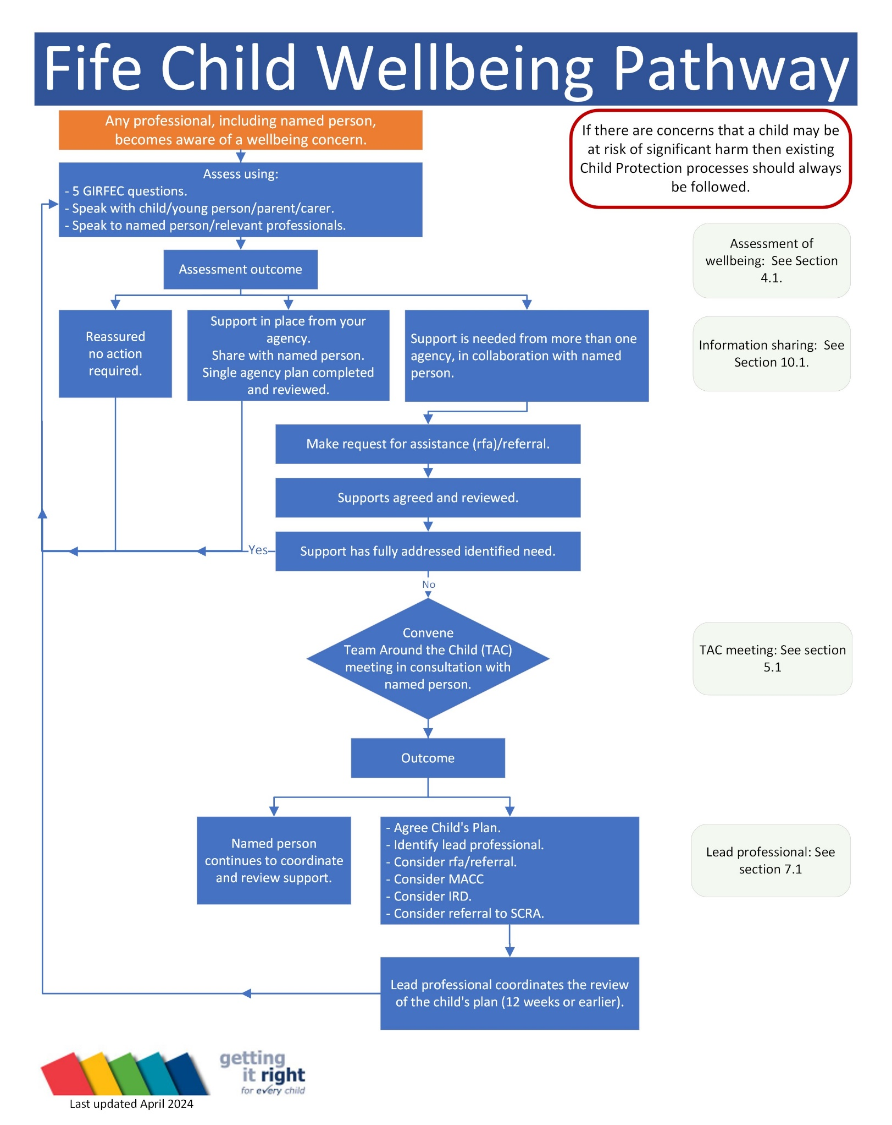

Appendix 2: Lead professional Dispute Resolution Process
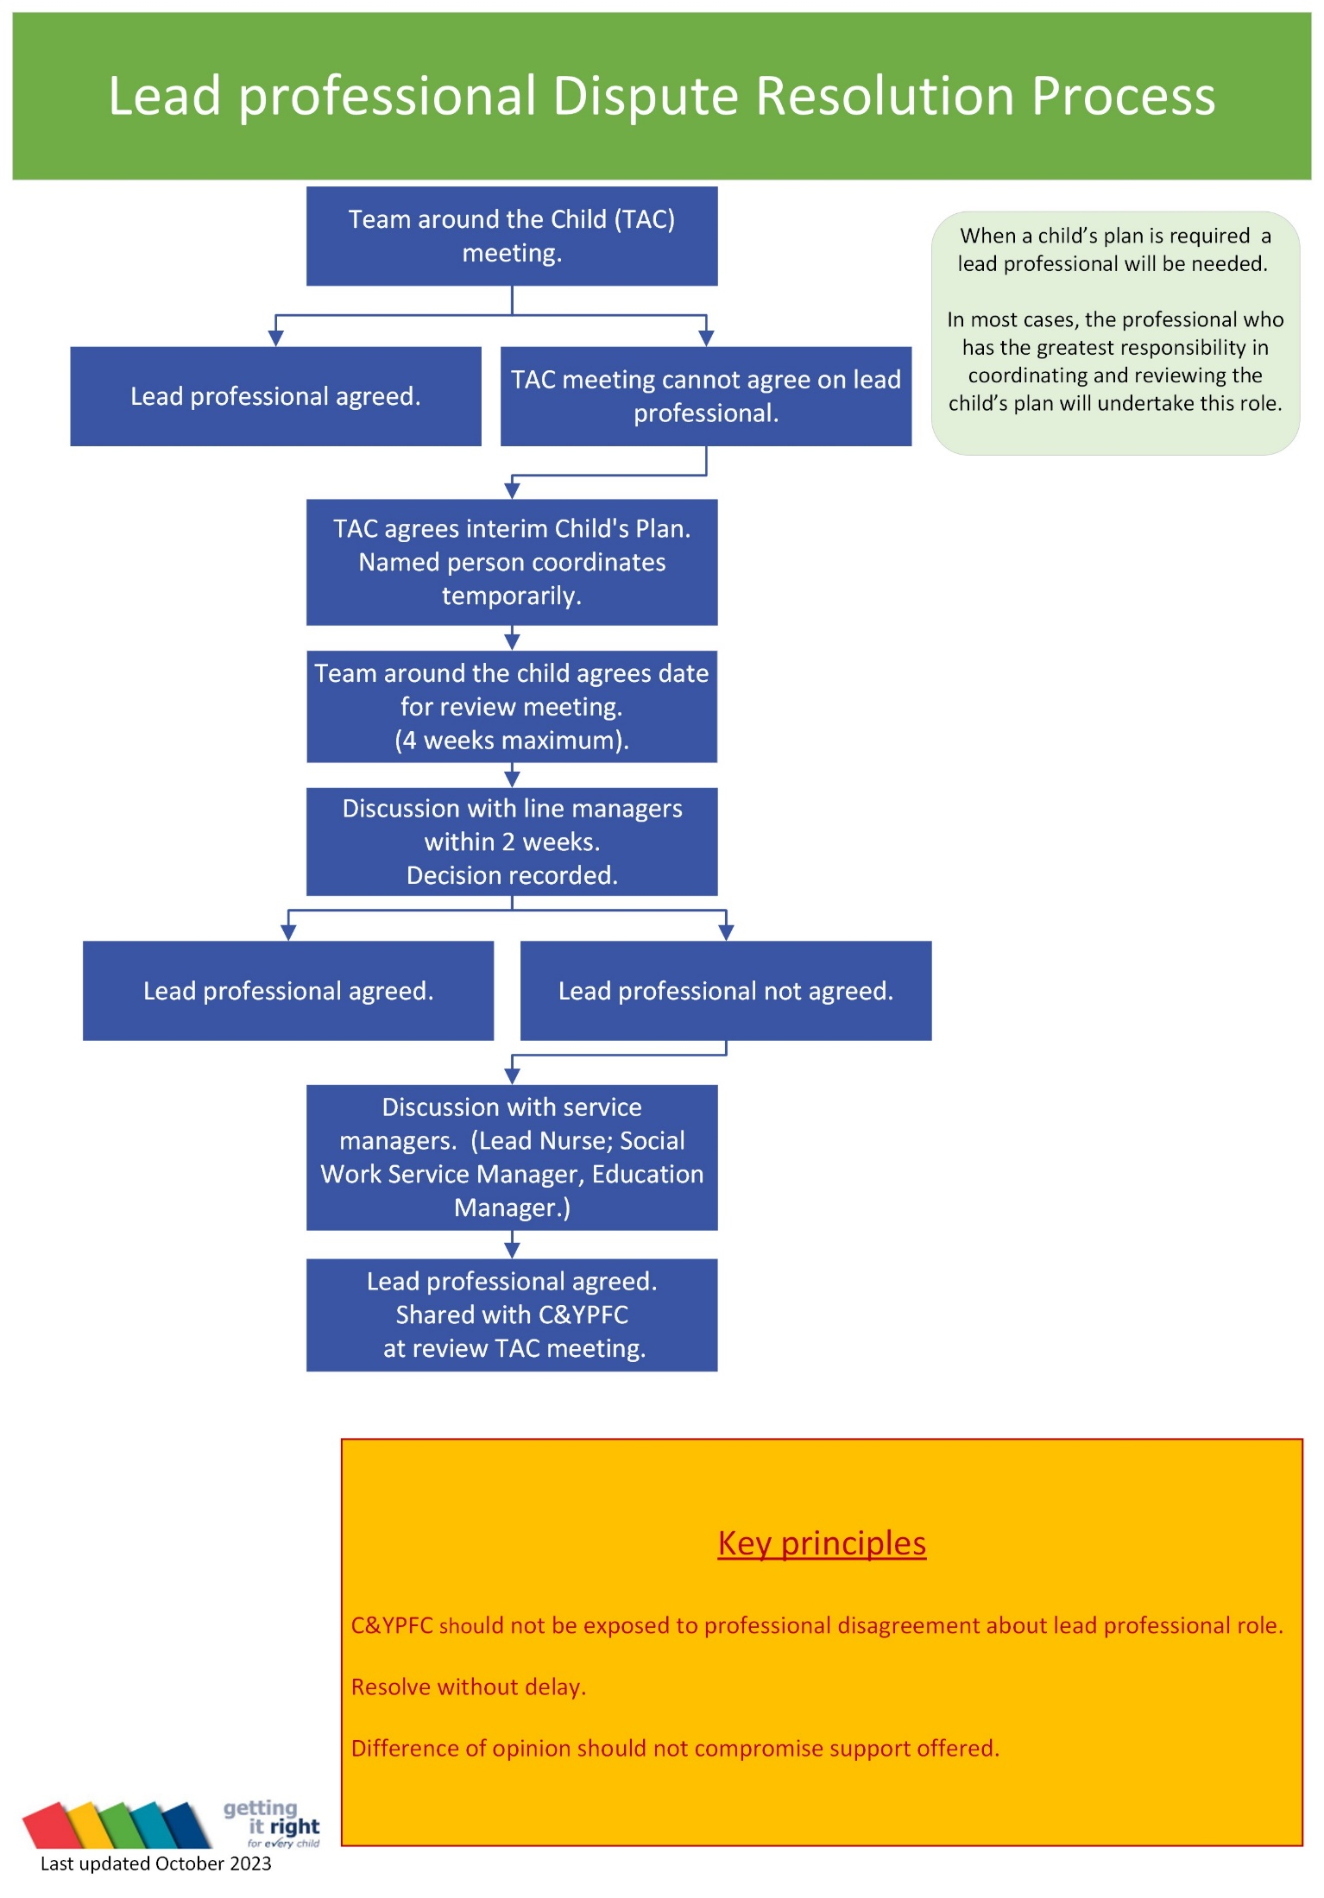

Appendix 3: Sharing Information Flowchart
